 |  |  | TAYSAN  COPPER–GOLD PROJECT  Batangas · Luzon · Philippines
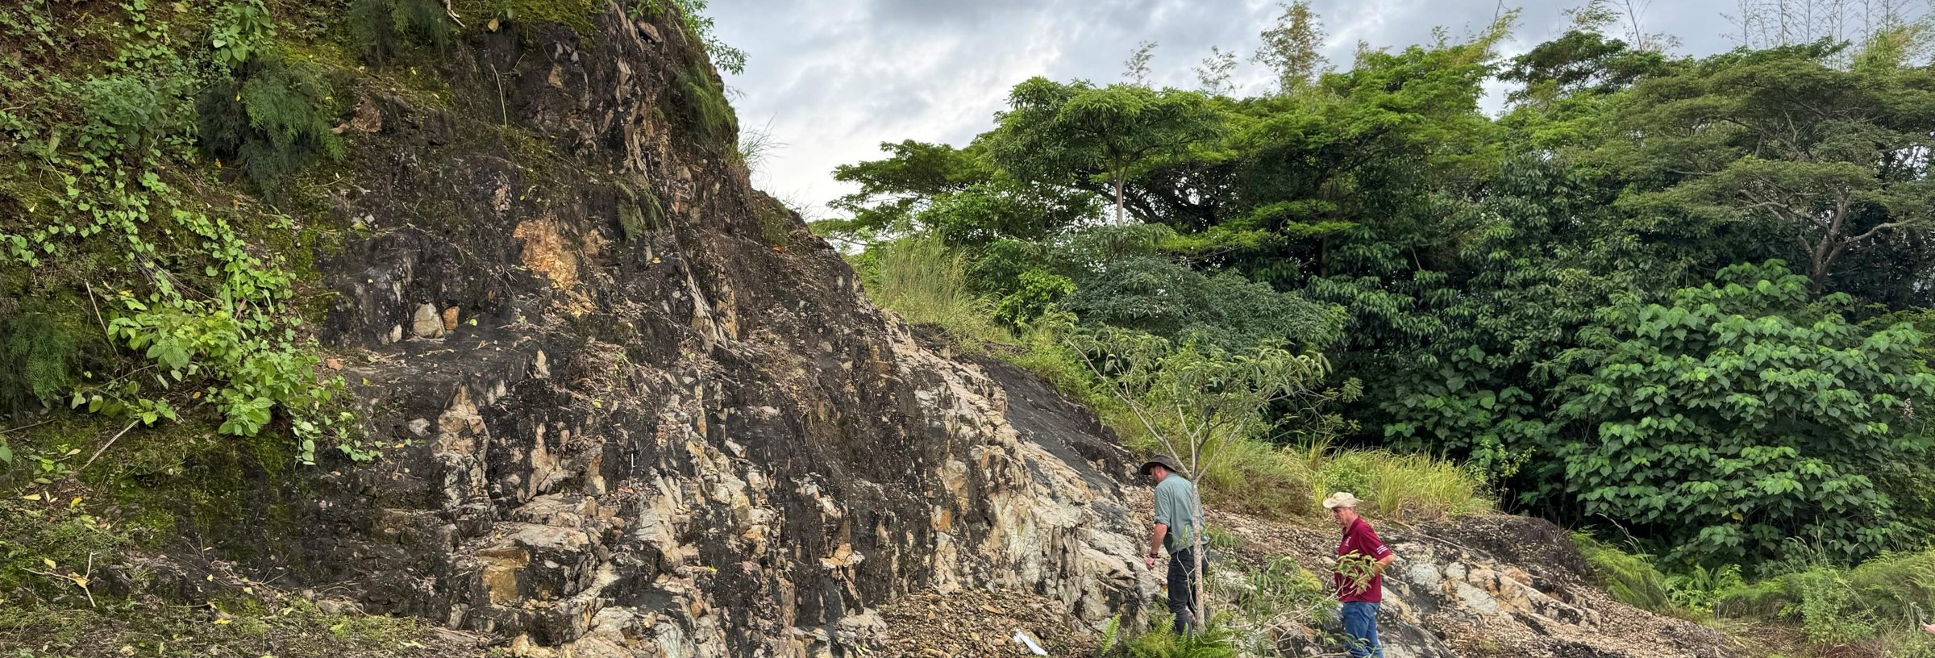
LARGE · ADVANCED · CONNECTED
A 968-million-tonne copper-gold porphyry,
two hours from Manila.
An open-pit copper-gold project with a post-tax NPV of US$2.1 billion and a 0.8:1 strip ratio, located 20 km from a deep-water port with grid power and sealed road access already in place.
 | 968 Mt  MINERAL RESOURCE  @ 0.30% CuEq (M+I+I) | US$2.1Bn  POST-TAX NPV₈  Independent Technical Report 2026 |  | 48%  POST-TAX IRR  Base-case metal prices |  |  |  |  | 3.6 yrs  PAYBACK  on US$523M pre-production capex
 | 01 · THE DEPOSIT  A large deposit that starts at surface  Taysan is a copper-gold-silver porphyry that outcrops at surface. Approximately US$50 million of historical expenditure, including 82.4 km of drilling in nearly 300 holes, has defined a Mineral Resource of 968 Mt at 0.30% CuEq. The drill database has been independently verified and a pre-feasibility study has been completed.  Measured and Indicated Resources total 459 Mt. The deposit remains open laterally and at depth.  Contained metal within the NI 43-101 Mineral Resource (M+I+I), before processing recoveries. |  |  |  |  |  |  | 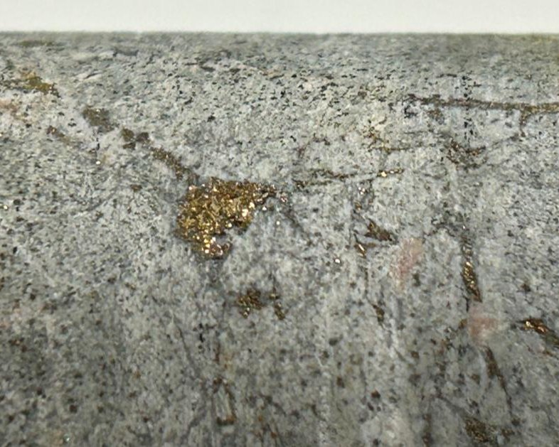  Coarse disseminated chalcopyrite in Taysan drill core. Simple mineralogy supports good liberation and a clean concentrate.
  2.1 Mt  CONTAINED COPPER |  | 2.8 Moz  CONTAINED GOLD |  | 21 Moz  CONTAINED SILVER
 | 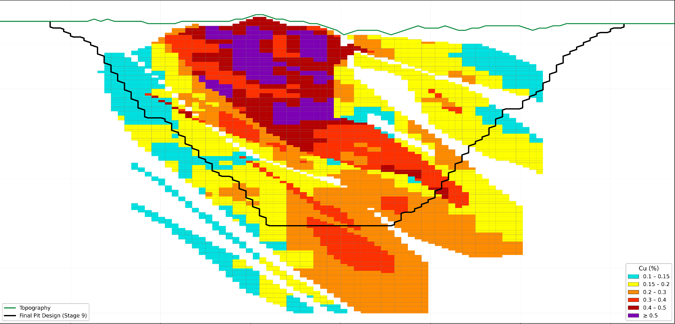  E–W cross-section showing copper grade and the final pit design. Higher grades (≥0.4% Cu, purple and dark red) occur at surface in the starter pit area. Source: Independent Technical Report, IMC Mining, 2026. |  |  |  |  | 02 · THE MINE  Low strip ratio, high-grade start  Higher-grade material occurs at surface. The mine plan starts with a 7.5 Mtpa pit on this zone, then expands to 15 Mtpa funded from operating cash flow.  - Starter pit: 7.5 Mtpa for six years at 0.64% CuEq  - Expansion: 15 Mtpa over a ~28-year mine life  - Strip ratio 0.8:1 and C1 cash cost of US$2.02/lb Cu  - Conventional flotation: 90% Cu recovery to a 25% Cu concentrate  - By-product credits from gold, silver and magnetite
HAWK COPPER Taysan Copper-Gold Project · Project teaser · 2026 01

TAYSAN AT A GLANCE
Infrastructure · Economics · Market · Jurisdiction · Board
03 · INFRASTRUCTURE
Established regional infrastructure
Taysan is located in an established industrial area of Batangas province, alongside cement plants and quarries. Port, grid power, water and sealed roads are in place. Infrastructure that would normally add hundreds of millions of dollars to the construction CAPEX of a greenfield mine project.
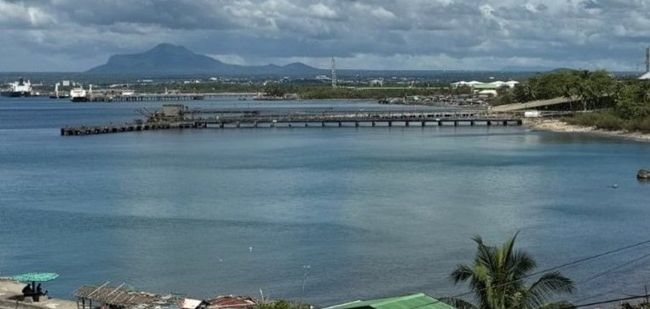 |  |  | 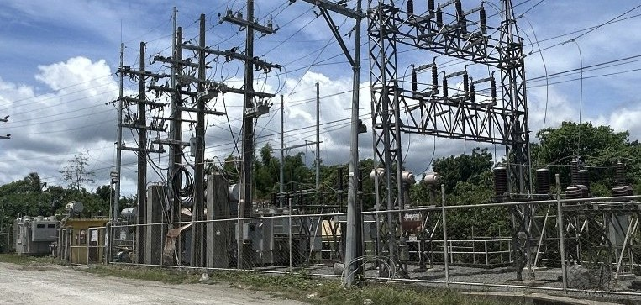 |  |  | 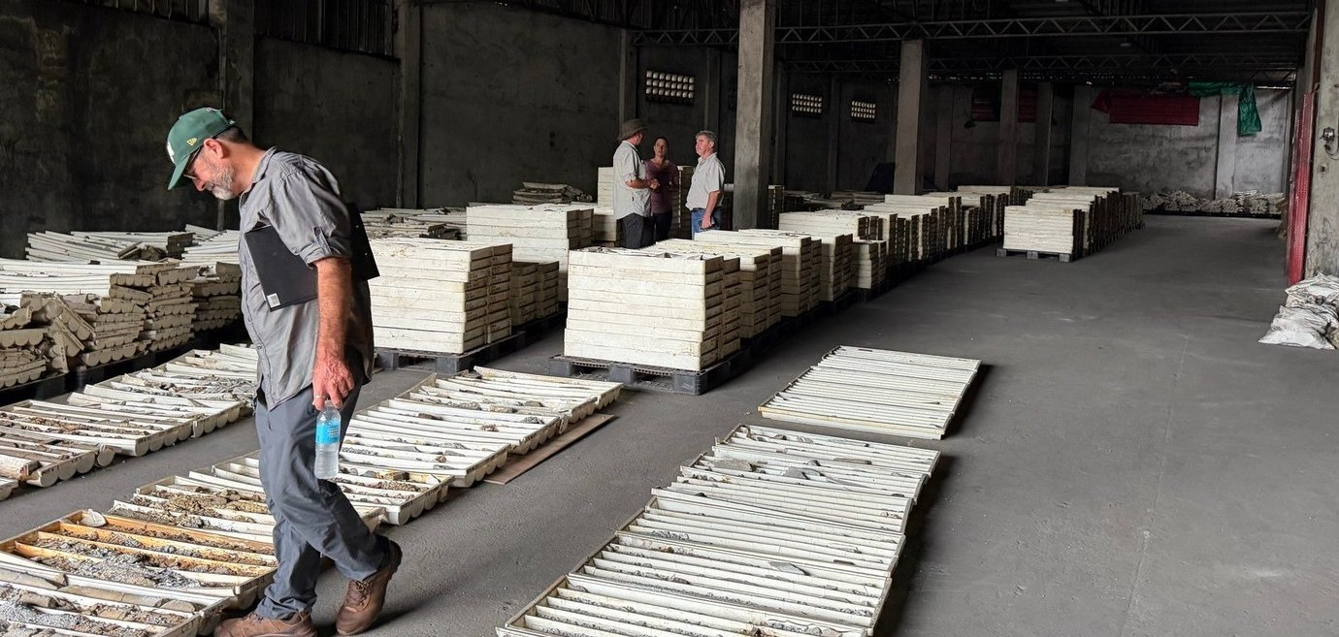
BATANGAS DEEP-WATER PORT |  |  | SUBSTATION ON SITE |  |  | 82.4 KM OF VERIFIED CORE
20 km  to the Batangas deep-water port | ~2 hrs  by expressway and sealed road from Manila |  |  | 69 kV  grid connection and substation on site |  |  | 75%  of process water recycled from tailings

 | 04 · ECONOMICS  Sensitivity to metal prices  Post-tax NPV₈ exceeds US$1.1 billion in all modelled price scenarios and reaches US$3.1 billion at the upper end of the range.  Post-tax NPV₈ (US$M) by copper (US$/lb) and gold (US$/oz) price. Base case boxed. Source: Independent Technical Report, IMC Mining, 2026. |  |  | 05 · THE MARKET  Copper market fundamentals  Demand from electrification, grid investment and data centres is rising, while global average mined grades have declined from ~2% to ~0.55% over the past century. New supply is increasingly sourced from large, lower-grade porphyry deposits.  - Supply deficit: ~2 Mt forecast by 2030 (J.P. Morgan)  - Price outlook: US$12,000–14,000/t bank consensus by 2030  - Grade: large producing pits mine 0.3–0.5% Cu; Taysan’s first five years of mill feed average ~0.45% Cu plus by-product credits
  Au \ Cu | $4.20/lb | $4.80/lb | $5.40/lb | $6.00/lb | $6.60/lb
  $4,000/oz | 1,152 | 1,558 | 1,965 | 2,371 | 2,777
  $4,250/oz | 1,222 | 1,628 | 2,034 | 2,440 | 2,846
  $4,500/oz | 1,292 | 1,698 | 2,104 | 2,510 | 2,916
  $4,750/oz | 1,361 | 1,767 | 2,173 | 2,580 | 2,986
  $5,000/oz | 1,431 | 1,837 | 2,243 | 2,649 | 3,055
 | 06 · JURISDICTION  Supportive regulatory framework  - Executive Order 122 (2026): copper designated a national-priority critical mineral  - Green Lane (EO 18): concurrent permit processing within statutory timeframes; Hawk application submitted  - RA 12253 fiscal regime: 1–5% royalty; windfall tax only above a 30% margin  - FTAA: 100% foreign ownership available |  |  |  |  | All critical mineral projects shall be considered as national priority projects… recognising that these resources are crucial for the Philippines’ national security and development.  EXECUTIVE ORDER NO. 122 · 21 AUGUST 2026
07 · UPSIDE TO THE BASE CASE
1 RESOURCE GROWTH  Infill of Inferred material currently treated as waste, and pit-wall extensions. Potential to exceed 1 billion tonnes. |  | 2 EXPLORATION  Untested near-pit targets, including a chargeability anomaly with a historical intercept of 62 m @ 0.65% Cu. |  | 3 COARSE GRIND  Flotation at 450 µm rather than 106 µm, with potential to reduce power and operating costs. Test work ongoing. |  | 4 SURFACE OXIDE  ~20 Mt of oxide material at 0.32% Cu, outside the current mine plan.

08 · BOARD
Rick Anthon  CHAIRMAN  Resources lawyer with 30+ years’ experience. Former Director of Corporate Development, Allkem. Chairman, Savannah Resources. |  | David Minchin  DIRECTOR & CEO  20 years in exploration geology and private equity. Directed approximately US$600 million of investment into exploration and development projects on five continents |  | Craig Foggo  NON-EXECUTIVE DIRECTOR  20 years in mining operations and private equity, including operational experience in the Philippines. |  | Richard Seville  PROPOSED NON-EXEC DIRECTOR  Founder and CEO of Orocobre for 12 years, from IPO to acquisition by Rio Tinto for $6.7Bn. Director OZ Minerals until A$9.6Bn acquisition by BHP

Further information
Meet the Hawk Copper team, or contact:
info@hawkcopper.com · www.hawkcopper.com
This document is for information only. It does not constitute an offer to sell, or a solicitation of an offer to buy, any securities, and must not be relied on in making any investment decision. Mineral Resource figures are from the NI 43-101 Mineral Resource Estimate (0.1% Cu cut-off); economic figures are from the Independent Technical Report (IMC Mining Pty Ltd, Report IMC1603, effective 1 September 2026), base case Cu US$5.40/lb, Au US$4,500/oz, Ag US$75/oz, magnetite US$100/t, with recoveries of 90% Cu, 69% Au, 55% Ag and 94% magnetite. CuEq is reported in situ. Market data from LME, Goldman Sachs, Citi and J.P. Morgan. This document contains forward-looking statements that involve risks and uncertainties; actual results may differ materially. © Hawk Copper and Gold Ltd 2026.

